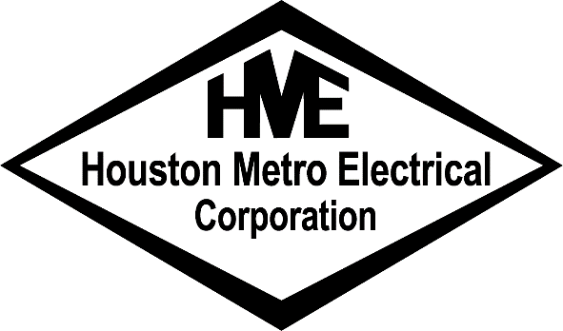

July 12, 2017

Zeiben Group
1980 Post Oak Blvd. Suite 2020
Houston, Texas 77056
Attn.: Development

Re: Introduction Letter

Dear Mr. Lee Zeiben,

We appreciate this opportunity to present our qualifications and to provide you with this information about our company.

Since 1977, Houston Metro Electrical Corporation has provided builders and developers with skilled and qualified journeyman and apprentice electricians capable of performing quality installations within the required construction schedule. Our field crews are supported by a professional organization of engineers, master electricians, and supervisory, office, and warehouse staff that understands the importance of job site production and materials management.

We are presently one of the most competitive electrical contractors specializing in multi-family residential construction. We are fully insured, bondable, and licensed in all local municipalities and all other major municipalities throughout the State of Texas.

At Houston Metro Electrical Corporation our continued success is based upon our constant dedication to professionalism within the electrical industry. We trust that our reputation as a dependable and competitive electrical contractor will allow us to become a part of your construction team.

Upon your request, we would be pleased to furnish you with specific financial and insurance information. Please find attached a listing of several projects in progress or recently completed representative of our capabilities. You can also visit our website at www.houstonmetroelectric.com

Sincerely,
Houston Metro Electrical Corporation

Carrie Shirley
Estimator

