Dear Miss/Sir,

Good days! Wish everything goes well with you and your esteem company.

This is Tracy from Jinsun Lighting Co., Ltd in Zhongshan, Guangdong Province, China. Our company is a professional manufacturer specializing in producing Track Light, Downlight, Spotlight, Hotel light, LED Light Engine, High-end Aluminum Outdoor Wall Lamp, and so on.With competitive price and high quality,we have been engaged in this field for 5 years.

Our market covers most of European countries (including England, Germany, Poland, France…), and America, Canada, South Africa, South East countries. Our clients are very satisfied with our products and our service.

We got you contact from Your Company Website, and know that you are finding some led lights. By the way, the 21st Guangzhou International Lighting Exhibition & LED Asia will be held in June 9th to 12th, 2016, we will wait for you in the No.F08, Pavilion 9.3, welcome to visit our stand and products.

Here are some pictures of some our products:

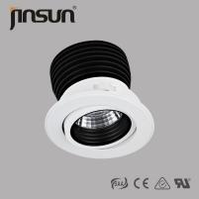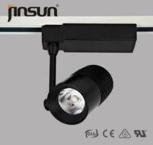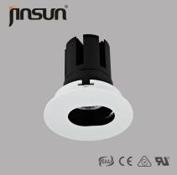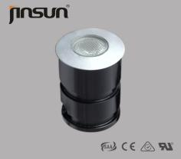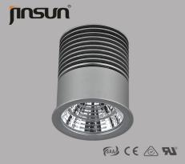

We have many other different categories and specifications, if you have interest in any kind of our product, please do not hesitate to contact us.

Advantages of our products  are as follows:

1.Original citizen/bridgelux cob

2.patented honeycomb heatsink

3.high quality 6063 lathe aluminum

4.CRI>80,PF>0.9

5.50000hours lifespan

6.australia standard plug wire

 If any necessary,pls feel free to contact us.Tks so much!

Best Regards

IMG_256

**Tracy Lee**

Mob:+86-13421458176

Skype:jinsuncall

Email:sales16@jinsunled.com

**Zhongshan Jingsen Lighting Co.,Ltd**

Tel:+86-0760-88461929    Fax:+86-0760-88461939

Add:The 5th Floor,No. 19 Guangle Central RD,Lianfeng Xiaolan Town,

Zhongshan City,Guangdong,China.528415  
Web:www.jinsunled.com